Topic 4: Cross-Site Request Forgery (CSRF)

Abuse of Authenticated Session via Forced State-Changing Requests

1. Objective
The objective of this Proof of Concept is to demonstrate how a Cross-Site Request Forgery (CSRF) vulnerability allows an attacker to abuse an authenticated user’s active session to perform unintended actions without stealing session cookies or credentials.
This PoC focuses on misplaced trust in session cookies automatically sent by the browser.

2. Target Application Details
- Site Name: PortSwigger Web Security Academy
- Lab: CSRF vulnerability with no defenses
- URL Pattern:
https://<lab-id>.web-security-academy.net
- Category: Web Security Training Lab
- Type: Intentionally Vulnerable Application
- Environment: Controlled lab environment (ethical testing)

3. Vulnerability Overview
CSRF vulnerabilities arise when:
- A user is authenticated to a web application
- Session cookies are automatically included in requests
- Sensitive actions lack CSRF tokens or origin validation
- The server authorizes requests solely based on session presence
This allows attackers to force victims to perform actions unknowingly.

4. Proof of Concept – Sequential Execution Log

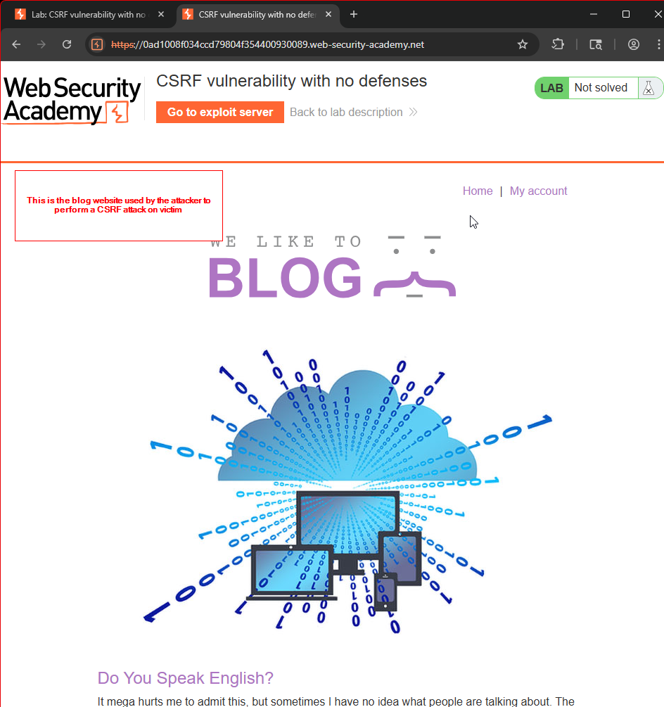

Figure 4.3 – Target Application Homepage
The attacker accesses the target web application and reviews available functionality.
Observation:
The application supports authenticated user actions such as profile updates.

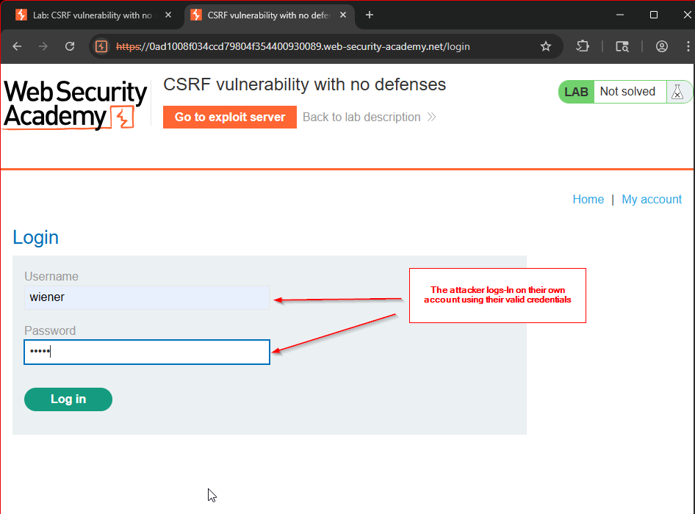

Figure 4.4 – Attacker Login
The attacker logs into their own account using valid credentials.
Purpose:
To analyze application behavior and identify state-changing requests.

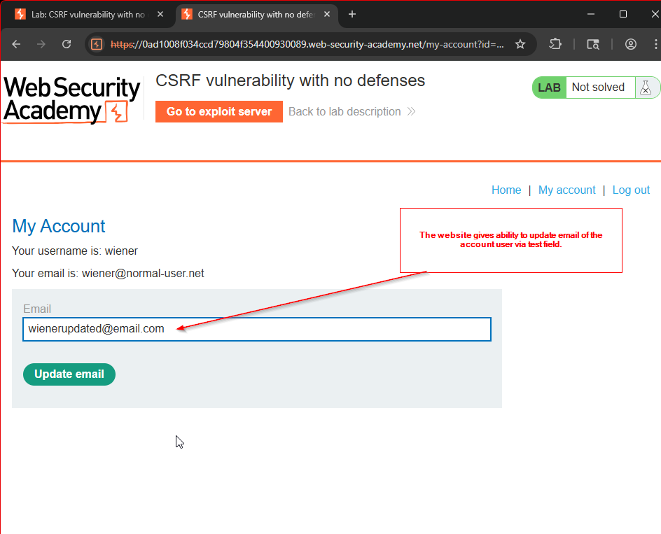

Figure 4.5 – Account Management Page
The “My Account” page allows users to update their registered email address.
Observation:
This is a sensitive state-changing operation suitable for CSRF testing.

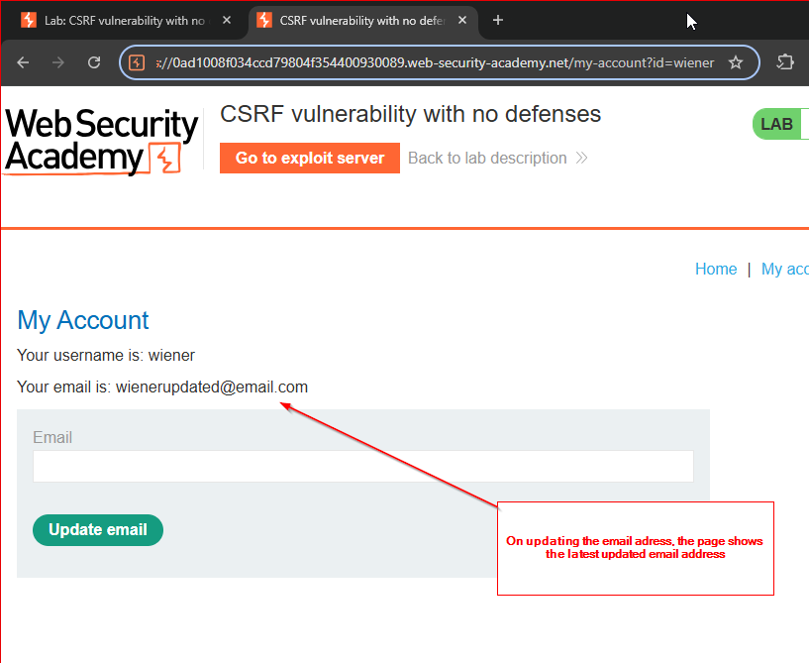

Figure 4.6 – Email Update Confirmation
After submitting a new email address, the application updates it successfully.
Conclusion:
The POST request directly modifies user data.

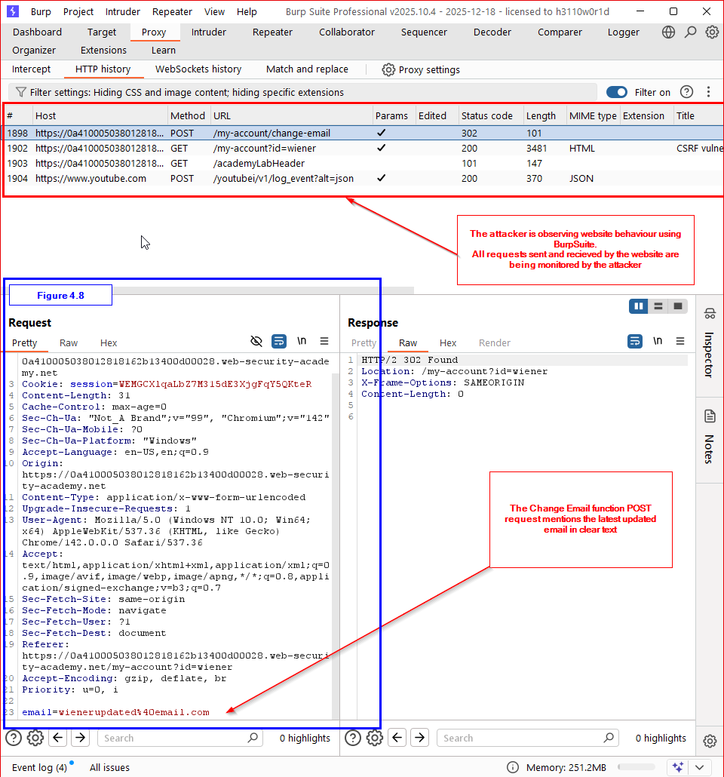

Figure 4.7 – Intercepting the Email Change Request
Using Burp Suite Proxy, the POST request to /my-account/change-email is intercepted.
Observation:
- Session cookie is present
- No CSRF token is included
- No origin or referrer validation is enforced

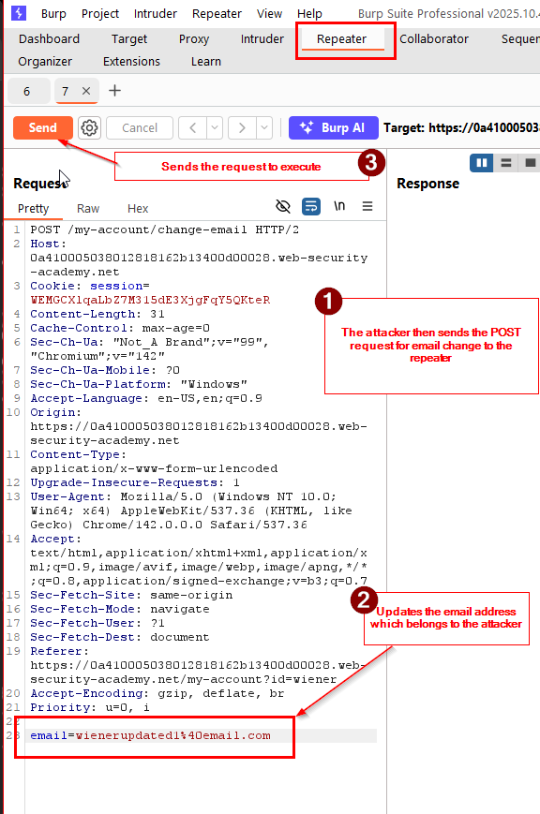

Figure 4.8 – Request Analysis in Burp Suite
The intercepted request is reviewed in detail.
Conclusion:
Authorization relies entirely on the session cookie.

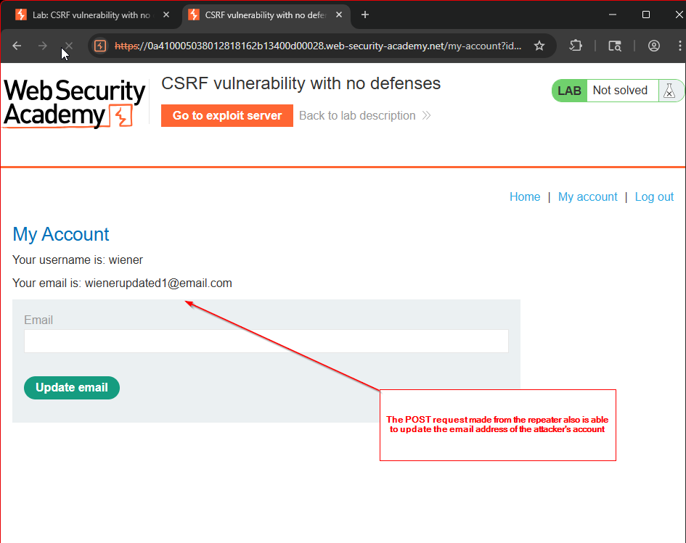

Figure 4.9 – Request Replay via Repeater
The same POST request is replayed using Burp Repeater.
Result:
The email address is updated again successfully.

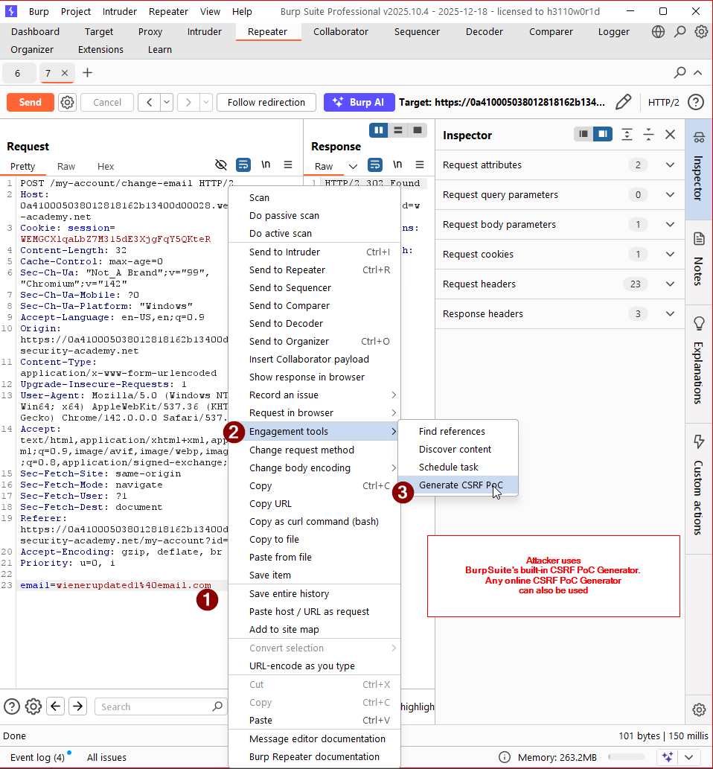

Figure 5.0 – CSRF PoC Generation
Burp Suite’s Generate CSRF PoC feature is used to convert the POST request into an HTML exploit.
Outcome:
An auto-submitting HTML form is generated.

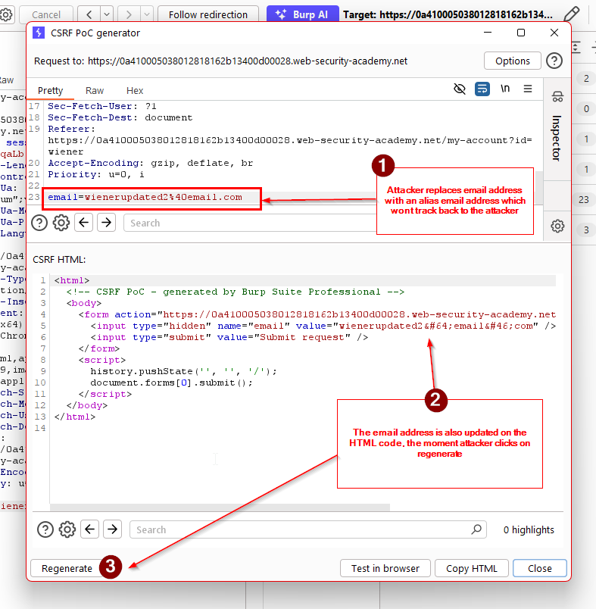

Figure 5.1 – CSRF Payload Review
The generated HTML form includes:
- Hidden email parameter
- Automatic form submission via JavaScript
Purpose:
To execute the request when a victim loads the page.

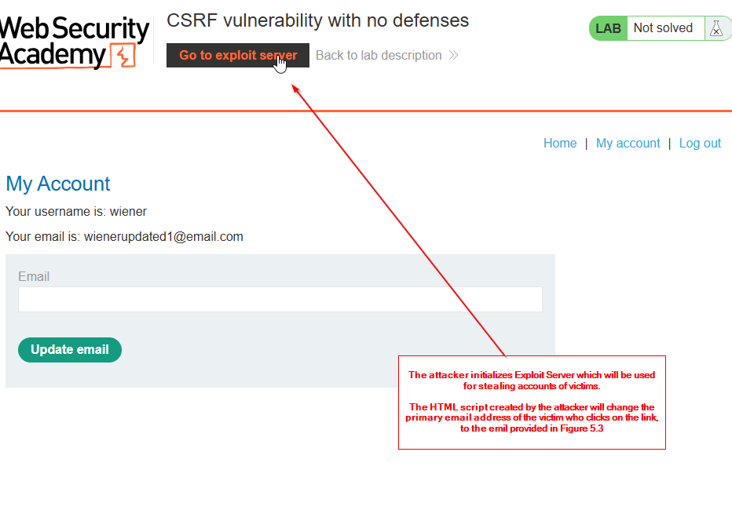

Figure 5.2 – Exploit Server Initialization
The attacker navigates to the Exploit Server provided by the lab.
Action:
The CSRF payload is prepared for hosting.

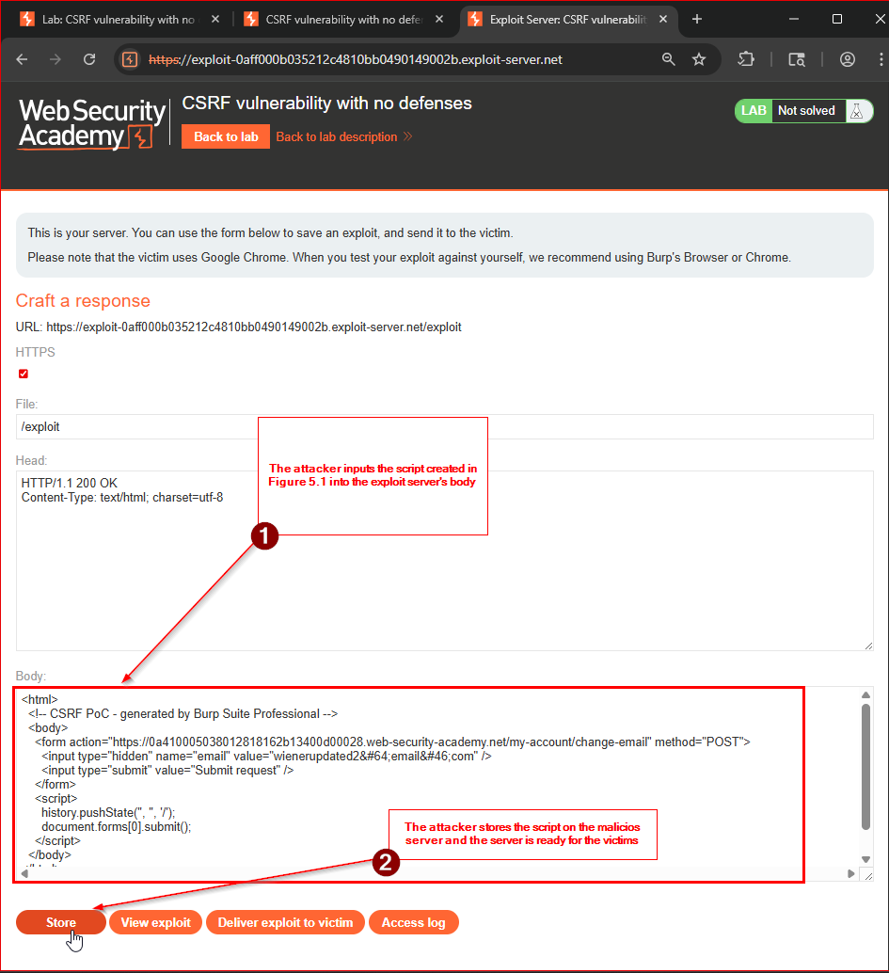

Figure 5.3 – CSRF Payload Stored on Exploit Server
The malicious HTML payload is saved on the exploit server.
Outcome:
The exploit server is ready to deliver the CSRF attack to victims.

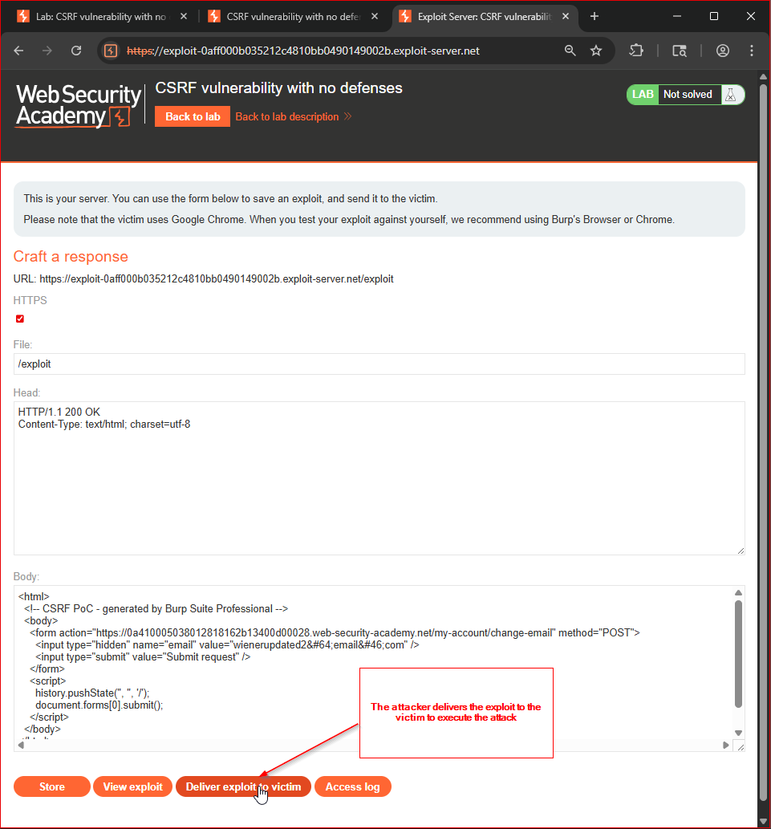

Figure 5.4 – Exploit Delivered to Victim
The attacker clicks “Deliver exploit to victim”. In real-life scenario, the delivery either happens through social engineering or via phishing attempts on the victim.
Action:
The victim’s browser is forced to load the malicious page on clicking it.

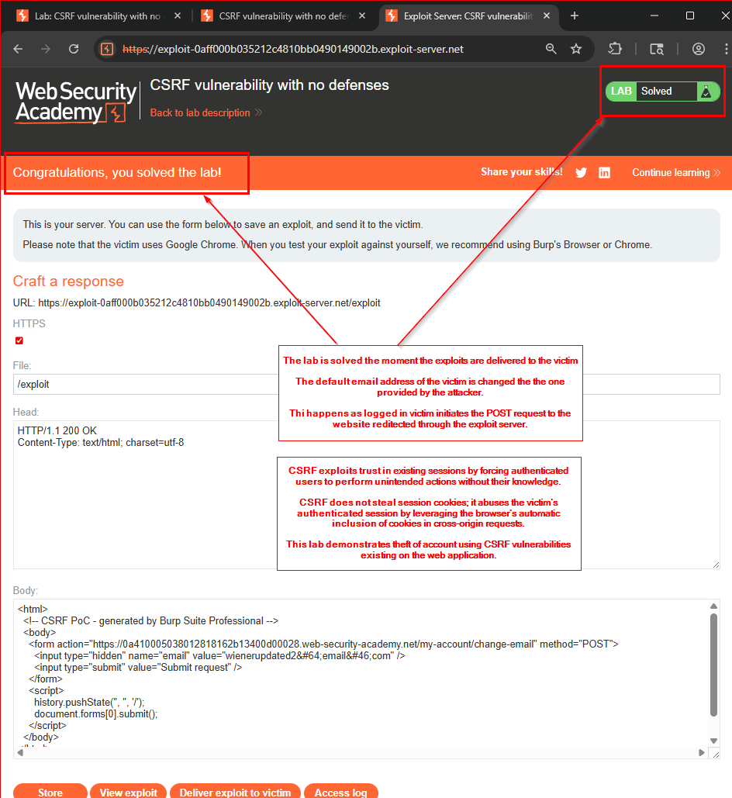

Figure 5.5 – Successful CSRF Execution
The victim’s authenticated browser automatically submits the forged POST request.
Result:
The victim’s email address is changed without their knowledge, and the lab is marked as solved.

5. Result
- No session cookies were stolen
- No credentials were compromised
- The attack succeeded by abusing the victim’s authenticated session

6. Security Impact
- Unauthorized account modification
- Potential account takeover via email manipulation
- Abuse of trusted authenticated sessions
- Difficult detection due to legitimate session usage

7. Root Cause
- Missing CSRF protection mechanisms
- No anti-CSRF tokens
- Reliance on session cookies alone for authorization

8. Key Insight
CSRF attacks exploit trust in authenticated sessions, not weaknesses in authentication mechanisms.

9. Attack Classification
Trust-Based Session Abuse Vulnerability
(Category: Cross-Site Request Forgery)

10. Conclusion
This PoC demonstrates how the absence of CSRF defenses allows attackers to force authenticated users to perform unintended actions. Secure session handling must validate user intent, not just session presence.

11. References
- PortSwigger – CSRF
https://portswigger.net/web-security/csrf
- OWASP – CSRF Prevention Cheat Sheet
https://cheatsheetseries.owasp.org/cheatsheets/Cross-Site_Request_Forgery_Prevention_Cheat_Sheet.html
- Burp Suite Documentation – CSRF PoC Generator
https://portswigger.net/burp/documentation/desktop/tools/generate-csrf-poc
- RFC 6265 – HTTP State Management Mechanism
https://datatracker.ietf.org/doc/html/rfc6265

